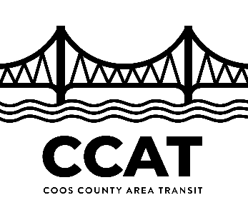
DIAL-A-RIDE APPLICATION
62 YEARS AND OLDER
Americans with Disabilities Act (ADA) | Demand Response Eligibility

- Fully complete application.
- If you have additional questions call the CCATD Accessible Transportation Customer Service at (541) 267-7111 voice, 7-1-1 TTY.

Please print or type
PART1 APPLICANT DATA

Name:
First Middle Initial Last
Street Address: Apt.#:
City: Zip Code: Day Telephone: ( ) Evening Telephone: ( ) Email Address:
Birth Date: / /
I am a Veteran of the US Armed Forces. Yes No

Mailing Address (if different from above)
Street Address: Apt.#: City: Zip Code:

By providing emergency/alternate contact numbers, you authorize CCATD or its representatives to contact the individuals listed regarding your Demand Response service.

Emergency Contact Person
Name:
First Last Relationship
Day Telephone: ( ) Evening Telephone: ( )

- Which of the following assistive devices, if any, do you use: (please check all that apply)
Cane | Manual Wheelchair | Boarding Chair | Prosthesis
White Cane | Powered Wheelchair | Service Animal | Communication Aid
Walker | Powered Scooter | Portable Oxygen | Crutches
Cart Other:

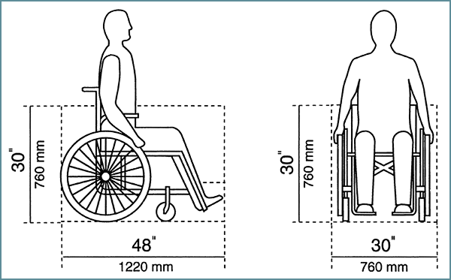
If you use a wheelchair or scooter:
Is it more than 30 inches wide? _____YES ______NO
Is it more than 48 inches long? _____ YES ______NO

- Do you need to travel with a Personal Care Attendant (PCA)? A PCA is someone designated or employed specifically to assist you meet your personal needs. CCATD cannot provide you a PCA and our drivers cannot serve as your PCA. (Select one)
No – You may still have someone travel with you whenever you wish
Sometimes – you travel with a PCA at your own discretion
Yes – You cannot travel alone and always need to travel with a PCA.
PART2 QUESTIONS ABOUT USING FIXED-ROUTE PUBLIC TRANSIT
- Do you now independently use fixed-route bus service? Yes No ___Sometimes

Have you ever had training to use the fixed-route bus service? Yes _No

Would you like to schedule time with our travel trainer? Yes _No

The information provided on this form is private data and is used to determine ADA paratransit eligibility. The ability to determine your eligibility is based on receiving all the information requested on this form. No information related to CCATD’s Accessible Transportation Services can be released to anyone else without the applicant’s signature. I certify that all information on this application form is accurate.
PART3 APPLICANT SIGNATURE

Applicant’s Signature: Date: / _/
*If the applicant is not his/her own guardian, the following information about the guardian is required:

Guardian’s Name: (please print)
First Last Relationship

Contact Phone: ( )

Guardian’s Signature: _ _ _ Date: / /
*If someone other than the applicant or the applicant’s guardian is preparing this form, please provide the following information about the preparer:

Name:(please print)
First Last Relationship

Contact Phone: ( )

Please submit completed application to:

Mail or Return in Person to:
CCATD
2810 Ocean Blvd SE
Coos Bay, OR 97420

Fax: 541-982-5381 or Email: skellyirvin@coostransit.org

STSuEP3 SUBMIT BOTH FORMS TOGETHER
STEP3 SUBMIT BOTH FORMS TOGETHER

